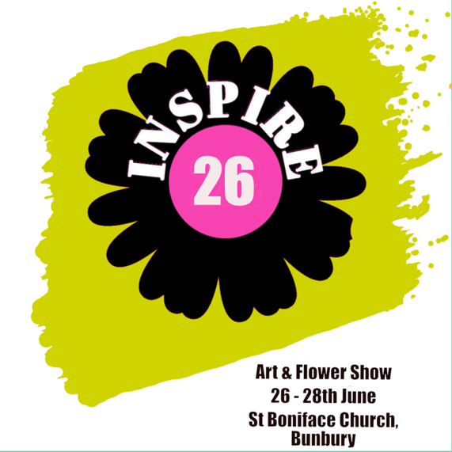

Bunbury’s got talent. Application Form. Artwork that is not for sale
Thank you for wanting to take part in the St Boniface exhibition. One piece of work may be submitted, but in the case of smaller pieces (for example pottery a maximum of 3 items)
All exhibits to be dropped off at St Boniface Church on the 22nd June between 1pm and 5pm or on 23rd June between 6pm and 8pm or by arrangement.
Artworks should be collected at the close of the exhibition on Sunday 28th June from 4pm to 6pm, or on Monday 29th June from 10am to 12 noon or 4pm to 6pm
This artwork is not for sale.
All exhibits should be labelled with a name on the back, phone number and title of artwork where appropriate.
Name ..................................
Address ....................................
Phone Number ...........................
Type of Artwork (embroidery, painting, pottery etc.) with a brief description. Title of artwork where appropriate

A rough size of the piece to be exhibited
If possible, please bring this receipt when collecting your work
Entries to be emailed to inspire26art@gmail.com Any queries phone 07860128427 We look forward to seeing you

