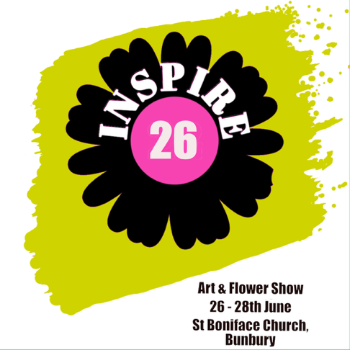

Application form
Please read the terms and conditions before completing. The application form is to be emailed to inspire26art@gmail.com
to Elaine Crotty tel. 07860 128427
Full Name ____________________________________ Age (if under 18)_____
Address ____________________________________________________________ __________________________
Postcode _________________________Telephone _______________Email_. _______________________
Images must be emailed. No artwork to be delivered at this point.
Title of Exhibit (original artwork only) | Medium | Size | Sale Price | Office Use only (received/selected/ Collected)
 |  |  |  | Rc’d Collected
 |  |  |  | Rc’d Collected
 |  |  |  | Rc’d Collected
● All artwork must be collected after the end of the exhibition
● No responsibility will be taken for work uncollected after the 29th June
● Uncollected work will not be stored unless by arrangement with the administrator.
● Inspire26 reserves the right to dispose of any uncollected work in whatever manner it sees fit. PLEASE BRING THIS RECEIPT OR ID WHEN COLLECTING YOUR WORK. By submitting this form by email you are agreeing to the terms and conditions (see separate document)

Signed.................................................date...................................................................

